Lesson:5 Unit:6  Traditions and customs | №1 Maykain Kazakh secondary school
Date: The 6th of March | Teacher name: Saule Tursukpayeva
Class: 2 | Number present: 9 absent:
Theme of the lesson: | Birthday Party
Learning objectives: | 2.L1 understand a range of short basic supported classroom instructions  2.S3 use a limited range of basic words, phrases and short sentences to describe objects, activities and classroom routines  2.UE8 use simple imperative forms [positive and negative] for basic commands and instructions
Lesson objectives: | All learners will be able to:  - Name the main vocabulary words  Most learners will be able to:  - Follow teacher’s instructions  Some learners will be able to:  - Do all suggested tasks without mistakes
Success criteria | Ss will be able to  - Name the new words  - Do the tasks correctly  - Make sentences about birthday party  - Try to find answers to the questions
Previous learning | Holidays in Kazakhstan and England
Plan
Planned timings | Planned activities | Resources
Beginning | Organization moment. Greeting.  T: Good morning, children. P:Good morning, teacher.  The pupils sing the song “Hello”  T: How are you today?  P: We are OK, good, great, wonderful, fine. Pupils show.  P: Greeting the guests  Hello! My name is….. .  T: What is the day today?  What season is it now?  What is the weather like today?  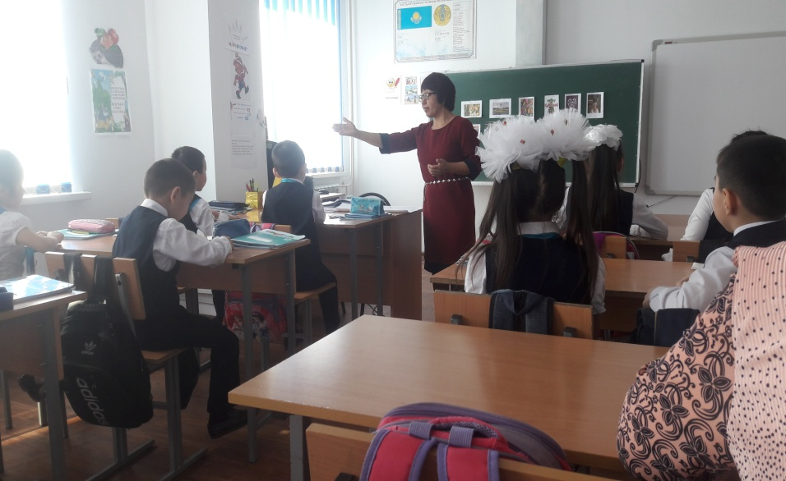  Pupils make a circle and say wishes to each other  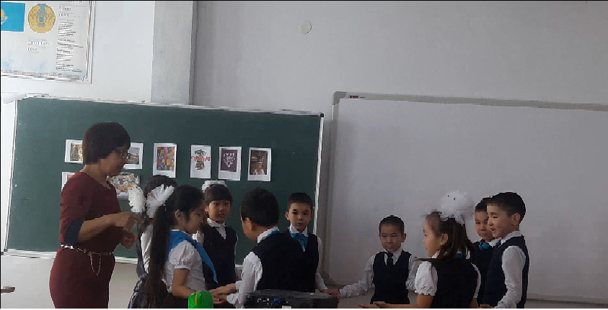 | “Hello” song
Checking the H\W | T: Let’s play a game with a ball  T: We sing, dance and give presents.  What holiday is it? – New Year. etc.  Show me the picture(pictures on the blackboard) | Pictures
Lead in | Students watch the video about birthday party  T: What holiday is it?  P: Happy birthday  Pupils put the question How old are you? to each other. | Video
Middle  End | Pre-teaching  Teacher presents some pictures implying birthday party on interactive board.  Drilling  Pupils look, listen and repeat the words after the teacher( chorus, boys, girls, individual)  Let’s play a game “What’s missing? “  Practice  - Birthday card  - The cake is red  - Draw 8 candles on the cake  - There are 2 green balloons, 2 yellow balloons, 2 blue balloons  T: Assess yourself (on the Interactive board)  Energizer: singing the song and doing the actions  Worksheet №2  Match the word with the picture  T: Assess each other (on the Interactive board)  Listen  T: uses the pictures  Blow a ballon, give a present, wear a birthday hat, blow a candle, eat a cake  Listen and repeat  Listen and do  Work in pairs  Worksheet №3  Listen and put the number  - Give a present  - Blow a balloon  - Eat a cake  - Wear a birthday hat  - Blow a candle  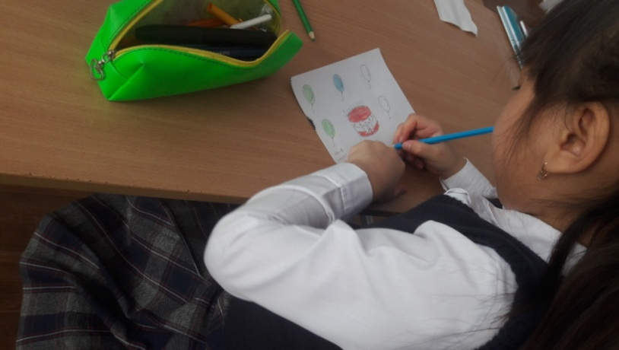  T: Assess each other (on the Interactive board)  Listening and reading a dialogue  Singing the song  H\W Learn the new words by heart, read the dialogue, make the cards.  T. asks CCQ  Teacher asks questions: Is it a candle? Is it a present? (Using the pictures)  Learners answer: yes or no  T: The lesson is over. Thank you for your work at the lesson. Good-bye.  P: Pupils sing the song " Bye Bye Goodbye” | 1)Interactive board(the pictures of Birthday Party)  Презентация Microsoft Office.  Worksheets  Colour pencils  AVI Video File  9 801 КБ Head and shoulders  Worksheets , pencils  Pupil’s Book  AVI Video File  9 801 КБ  19 Bye Bye Goodbye. Mp3  Knock Knock English

№1 Maykain Kazakh secondary school

Theme : Birthday Party
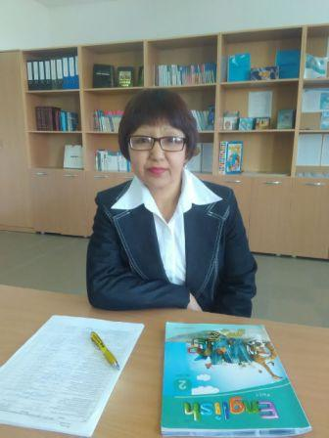

Grade 2
Teacher: Saule Tursukpayeva

2016-2017

